1. 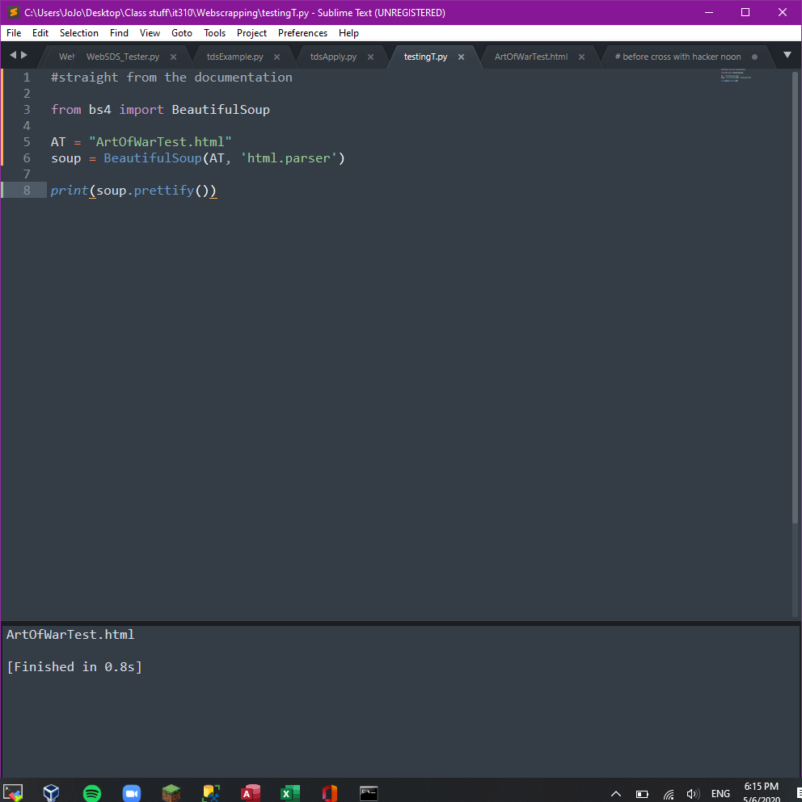
2. 
   1. Outputs the full name of the file given the file name without the .extension

Next we’ll try something with the file

1. 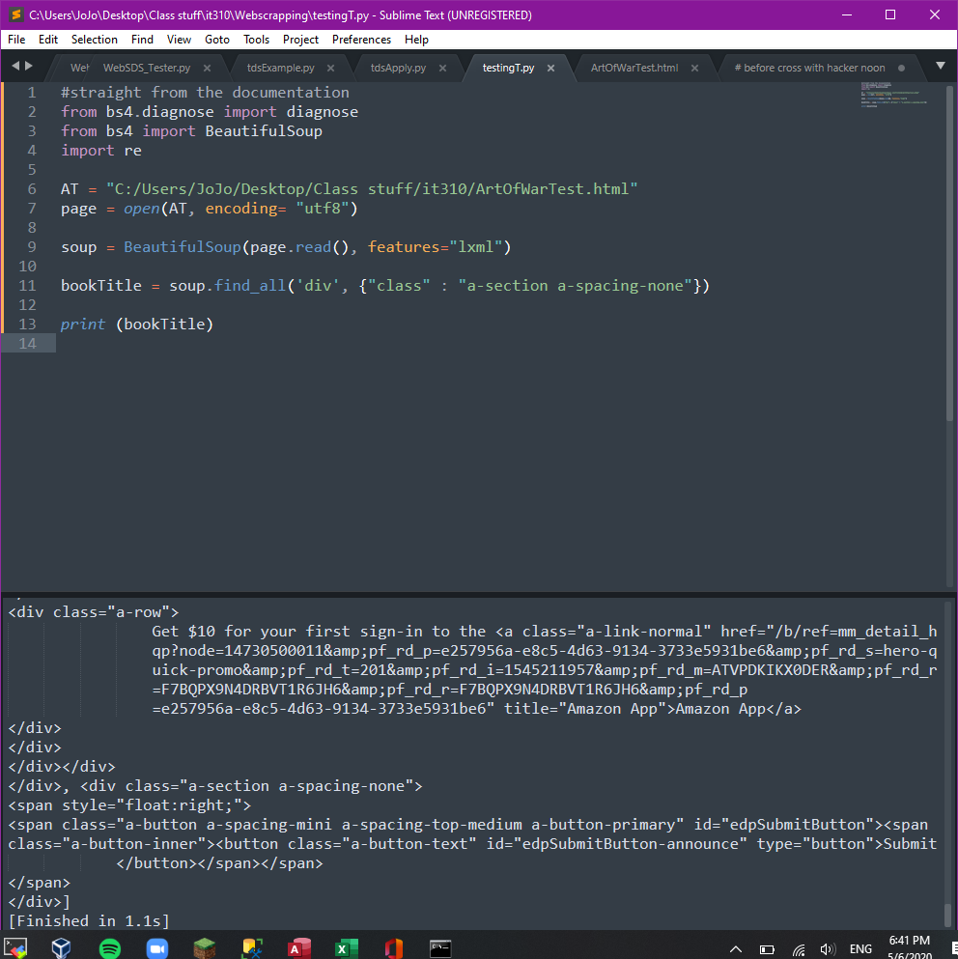
2. 
   1. So, with this code we supply the complete file path, and set it to “AT” then tell it to find the classes with “a-section a-spacing-none” in the div class.

Now let’s grab just the title of the book …

Part 1: change “soup.find_all” to “soup.find” and and the search loop for span within the relam

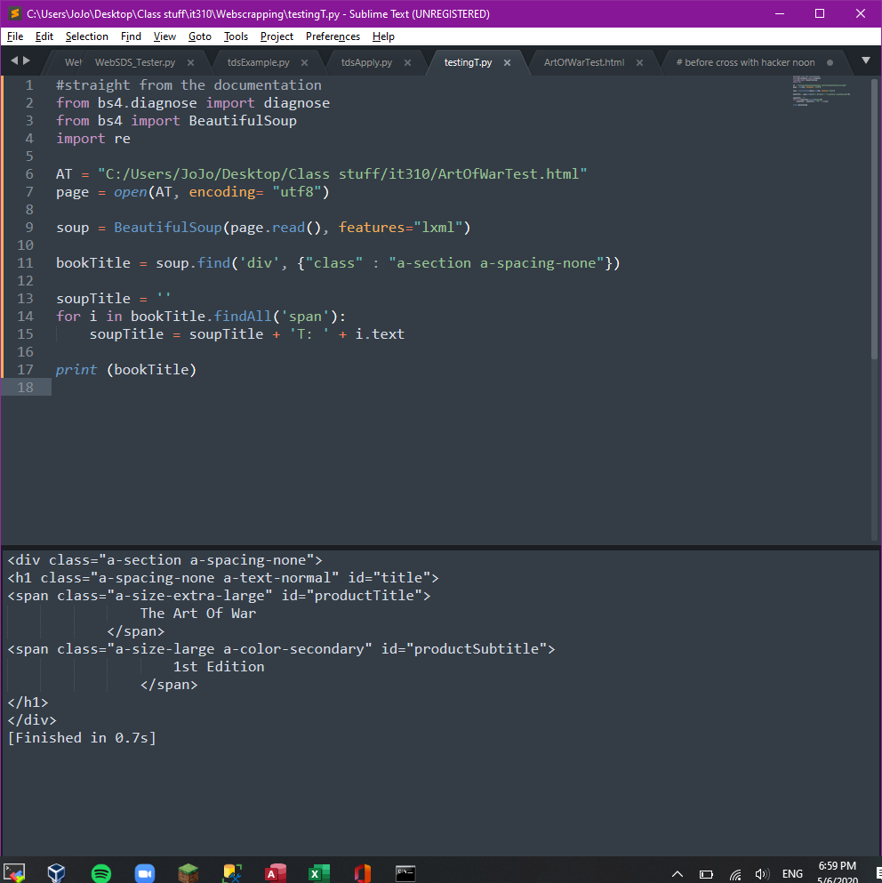



Part 2 :

change “bookTitle = “” “ to “soupTitle = “” “

And after some moving around we have the Title as well as file output :)

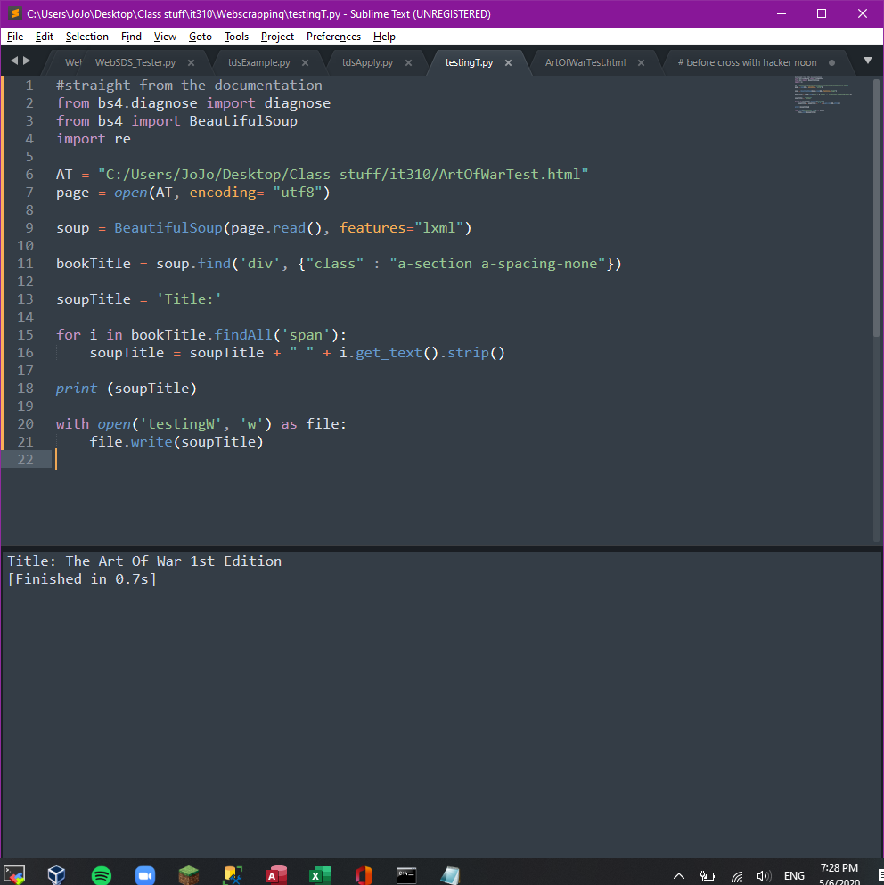



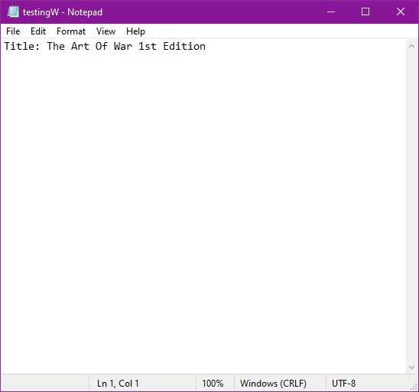

Part 3: Duplication for Price and clean up the format a bit

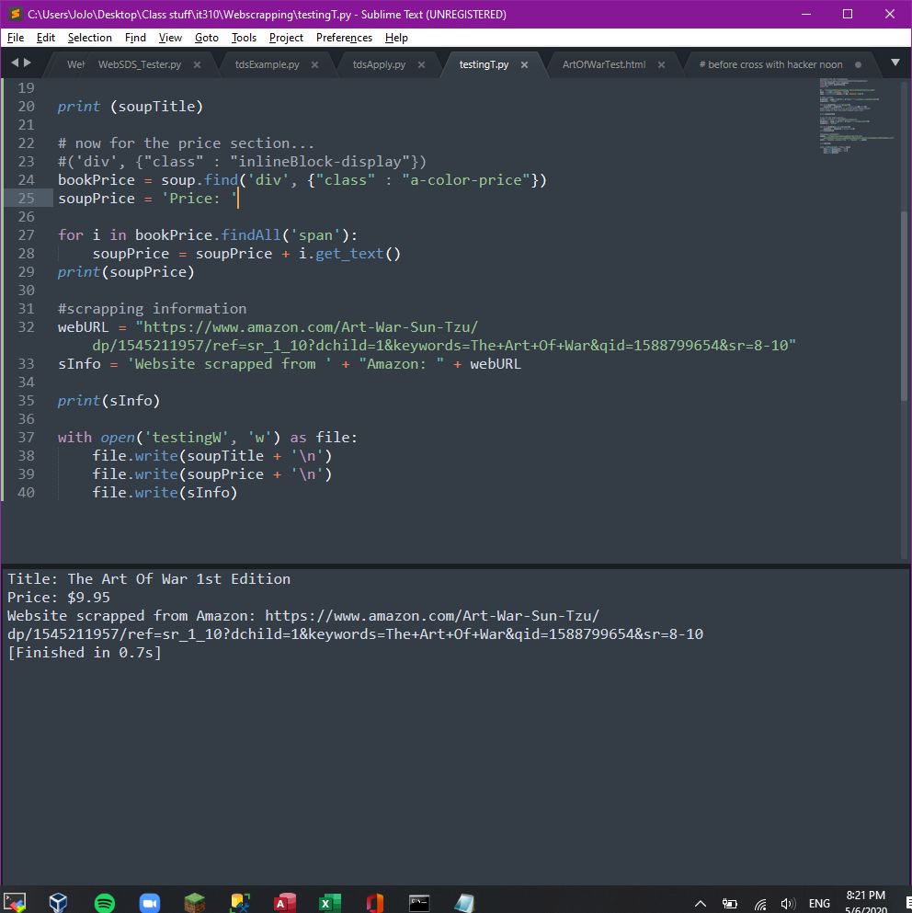



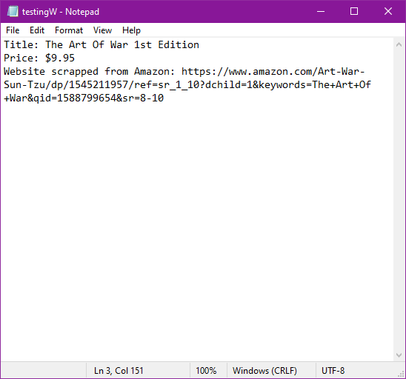

So… now we repeat for another site… monkaS should we create a seperate file then combine later?... nah I’ll give it an hour and if i run into problems then I’ll do it

Dupe for … OH! Let's do Barnes and Nobles!! Nah Ebay

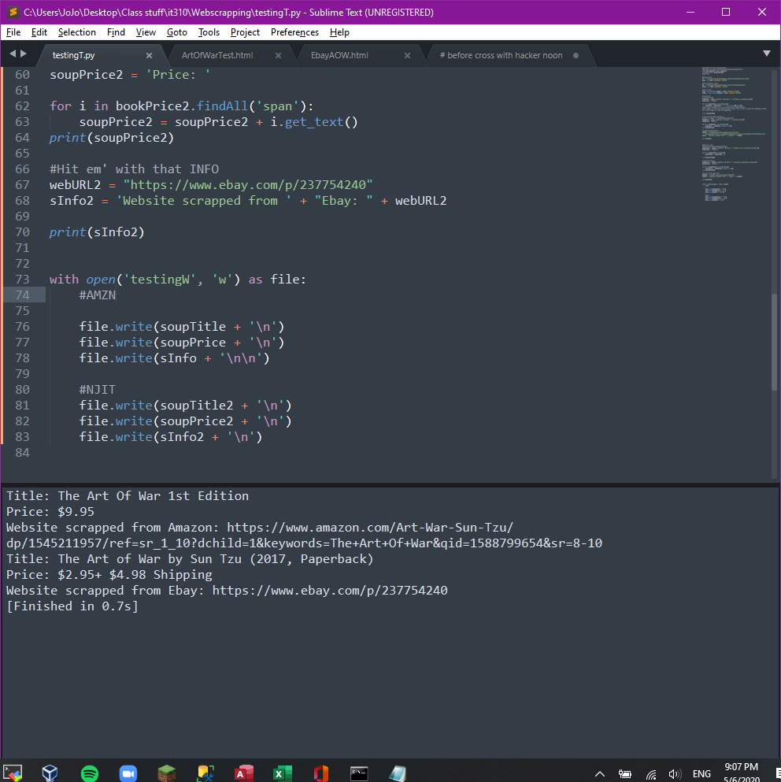



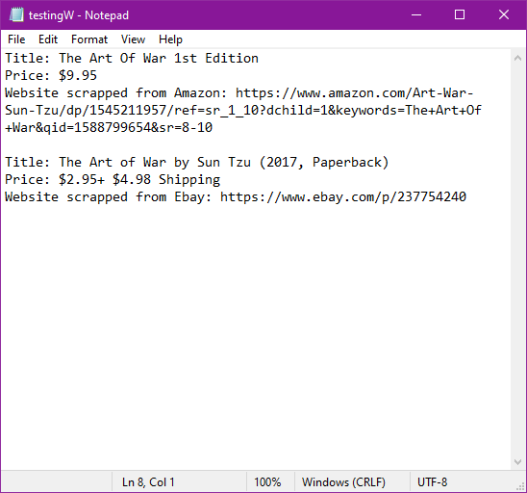

Extras? … maybe descriptions? I think im might want to put this into a data base eventually so… maybe not… what other numbers can we grab? OH! Quantity?

Verdict: Using BS means you are parsing a file, not the live website since you’re technically Dos’ing them and that;s not okay the files are just the source code so if I changed my code to handle requests then iit would work like my midterm. I tried that with proxies but there was so many problems so I went to check up on teh BS Docs to see what would happened if I started completly from scratch…. I think I found my niche :)

Examples for the video: